PASSOVER – 2019

I am very grateful for this opportunity to preach this morning. Thank you, Pastor Bruce, for this time.
This may seem like the wrong Sunday to be preaching on the Death, Burial and Resurrection of Jesus our Lord, which happened exactly to the hour and day of the observance of Passover, or Pesach in Hebrew.
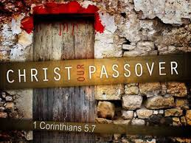
Here we are at the 7th of April, 2019, two weeks before Passover and Easter.
The Hall’s, our Missionaries to Israel, will be coming here from their home in Florida to lead us in a Pesach dinner, Saturday April 27 and John will preach Sunday the 28th, the week following Passover.
The message today, is that of the Spring Feasts, three feasts in one, Passover, Unleavened Bread and First Fruits. My prayer is that what I have to say this mourning will add excitement in anticipation for what the Hall’s will be doing in three weeks.
Back to today being the 7 of April. It just so happens, that today is a key day to the observance of Passover. Isn’t that strange how things work out?
No, ------- not strange, it’s God.

* This day, April 7, 2019, is the sighting of the new moon in Jerusalem. That makes today the 1st day of the month of Nissan, the beginning of months on God’s calendar. The beginning of the year is in the Fall, this is the beginning of months. Now if you go to a calendar that states that Nissan 1 or the new moon was yesterday, Saturday, that calendar was probably based on the Hillel calendar. A calendar most Jews go by today. A calendar established when the Jews were taken out of the promised land in 70 A.D. when they could not officially observe the new moon from Jerusalem.
*Another notable thing regarding God’s calendar: This year, 2019, has an extra month added to it. The last month of the year is Adar. To correct the calendar, an extra month, called Adar II, was added this year, just like we add an extra day to February every four years.
This extra month is important. It pushes the holidays later in the spring, which allows the grain to mature, so that there will be enough ripe grain to harvest and wave before the Lord as a Wave Offering on First Fruits.
On occasion, as the Spirit leads me during worship, I will raise my hands, waving them back and forth, offering myself as a wave offering to the Lord. We, the Church, are the Lord’s First Fruits. As such, I offer myself up as an Offering.
* Today being the 1st of Nissan, means that Passover starts Saturday, April 20, which is Nissan 14. And technically it starts the evening before at sunset.
Today I want to look at what the Spirit has stirred in me, that is:
Many, if not all, of the major Tenets of the Christian faith are illustrated in the Spring Feasts and are fulfilled in Jesus Christ.
Let me repeat that statement.
Tenets of the Christian faith are illustrated and are “Performed” as a ritual in the Spring Feasts and are fulfilled in Jesus Christ.
The Feasts are a teaching platform, if you will, to educate us on THE WAYS OF GOD.
There are many verses concerning the “Ways of God,” instructing us to live our lives according to His ways. And warning those that choose not to obey.
What does this phrase mean: The Ways of God? It means, in its most basic form, we are to learn how God does things, how He operates, how He handles things, His commandments, His instructions.
We are to learn them and operate our own lives based on these Ways.
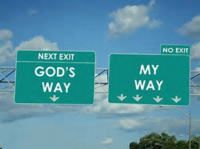
His ways are not our ways. Therefore, we must study and adopt His ways, because they do not come naturally to us.
Isa. 55:8 NASB “For My thoughts are not your thoughts, Neither are your ways My ways,” declares the Lord.
Plus, our God is a righteous God. If the word righteous means, being in right standing with God, how can He, God, be in right standing with Himself? To me this means, He operates, He lives His life, He obeys the same rules that He asks us to obey.
Unlike our government leaders of today, who enact different laws for themselves than for us.
And then, ……they break laws and are not prosecuted as the average citizen would be.
James 1:17 describes God this way. Every good thing bestowed and every perfect gift is from above, coming down from the Father of lights, with whom there is no variation, or shifting shadow.
No Variation or shifting shadow.
He does not change His position with the passing of time. When He is facing away, He does not say something different than when He was facing you, unlike our politicians of today.
Thank heaven for: Truth, Justice and the American….. I can’t really say that today. Truth and justice in America have been substituted with lies and political correctness. And isn’t political correctness just another way of saying a half-truth. And isn’t a half-truth a whole lie???
The only source of Truth and Justice is God.
God has said His ways are not our ways. We make choices every day, all day. Are we going to think and act His Way?
This slide illustrates this point. Note: There are four lanes going My Way, for broad and wide is the path that leads to destruction. There is only one lane marked God’s Way, for narrow is the path that leads to eternal life. Don’t worry about the highway being overcrowded on God’s Way, few will choose it.
Back to the Tenets of the Christian Faith, that are God’s Ways, which He is trying to teach us, through the Spring Feasts.
SUBSTITUTION

Substitution is the way, and we were talking about the Ways of God. God has designed a way for a Righteous God to deal with sinful man. The act of substitution was established right from the beginning.
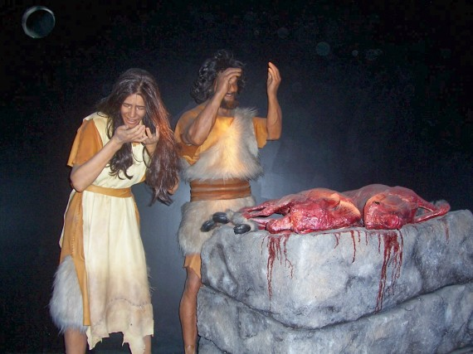

Adam and Eve sinned, ---- they disobeyed God, ----- they ate from the tree of the knowledge of good and evil. God made mankind to have fellowship with him. But God cannot have fellowship with sinful man. God provided an animal that was SUBSTITUTED, it shed its blood and provided skin for their covering.

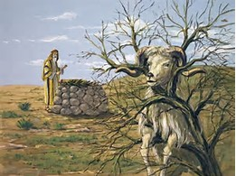
Abraham took his son to be offered as a sacrifice. God provided a substitute, a ram with its horns caught in a thicket.
At Passover, a lamb was sacrificed, its blood brushed on the doorposts, to redeem the life of the first born of that household. The lamb was the substitute.
Let’s look at another tenet of the Christian Faith; That of Fellowship with God, or put a different way, A Personal Relationship.
FELLOWSHIP / PERSONAL RELATIONSHIP
God created mankind for fellowship. He walked with Adam and Eve in the garden in the cool of the evening.
The Hebrew word for an appointed time is: MOED. The plural used for all the Feast days is MOEDIM. The Feast days were established by God as: times to meet with Him. This established an opportunity of “Knowing” each other and established a meeting time – in the cool of the evening, a Moed. We are to have a personal relationship with Jesus, not just know about him. We are to fellowship with Him. He says My sheep know My voice.
The next Tenet of Faith I want to look at is:
REDEMPTION

We are REDEMED by the blood of the lamb, the Lamb of God, Jesus.
Jesus was the ultimate substitution. He Redeemed us after He took our place on the cross, suffered for our sins and paid for our Redemption.
Exodus 12 are the instructions from the Lord to His people on the preparation to leave Egypt.
Exod. 12:1-13 NASB Verse 1. Now the Lord said to Moses and Aaron in the land of Egypt,
Note, the Lord said to Moses. The first five books of the Bible are referred to as the Law of Moses. It was the Lord that spoke to Moses. It is the Lord’s Law, that Moses wrote down. And there were TWO there to hear it, as required by law for an acceptable witness. Plus, one of Jesus’s names is: The Word. He is the Word of God, both the Old and New Testaments. He, Jesus, was from the beginning --------- RIGHT.
V2. “This month shall be the beginning of months for you; it is to be the first month of the year to you. V3.” Speak to all congregation of Israel, saying, ‘On the tenth of this month they are each one to take a lamb for themselves, according to their father’s household, a lamb for each household. V4. ‘Now if the household is too small for a lamb, then he and his neighbor nearest to his house are to take one according to the number of persons in them; according to what each man should eat, you are to divide the lamb.
Note: on the tenth of Nissan they picked an unblemished lamb.
When was it that Jesus rode into Jerusalem on a donkey? The 10th of Nissan. He was the unblemished lamb, even at his trial the High Priest declared, “I find no fault in Him.” The people started waving branches crying Hosanna, (Save, Now, we beseech thee). They were crying out to Jesus to save them. They were recognizing Him as the Messiah.
The unblemished lamb was kept at the home from the 10th to the 14th of Nissan, FOUR days.
Ok, today is the first of Nissan, in ten days, you were to go get your lamb and take it home and keep it there for four more days. During this time the lamb had to be fed and watered, it basically became your pet. When it came time to slit the throat of the lamb, it became very difficult. The homeowner had developed a personal relationship with the sacrifice.
We are to develop a personal relationship with the Lamb of God, our Savior, Jesus Christ.
There is the story of a Texas rancher inviting several guests over to observe Passover. Mid afternoon he took the Passover lamb to slit its throat, butcher it and put it on the grill for that evening’s meal. At 6 PM the guests started arriving, but the rancher was still not back from the grill. His wife informed her guests that her husband had gone to butcher the lamb. But when the lamb continued crying for its mother and he looked into its big round eyes, he could not do it. After two hours, balling like a baby, the rancher finally was able. So, the lady of the house announced, dinner will be two hours late.
The Passover Lamb is to teach us of our need for a personal relationship with Jesus and to appreciate what He has done for us and to develop this personal relationship.
V5. “Your lamb shall be an unblemished male a year old; you may take it from the sheep or from the goats. 6.’And you shall keep it until the fourteenth day of the same month, then the whole assembly of the congregation of Israel is to kill it at twilight.
Exactly when did Jesus die? It was 3:00 PM, Referred to as Twilight, or the 9th hour, according to Matthew 27:45-51, Mark 15:25 and Luke 23:44-46. This is exactly when the spear was thrust into Jesus’s side and He was declared dead.
Three hours later, 6:00 PM, the day of Preparation is over and Passover begins. When the High Holy Day of Passover begins, no work can be done. That is why they were in a hurry to get Jesus’s body down from the cross and put it in a grave.
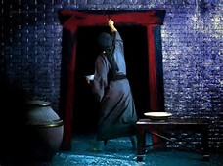
V7.’Moreover, they shall take some of the blood and put it on the two doorposts and on the lintel of the houses in which they eat it.
In preparing for this sermon, I ran into an interesting comment concerning the blood on the doorposts. It went this way. Note on this painting, the blood goes completely up the sides of the doorposts and across the lintel, except on the left doorpost at the top there is a small gap.
The commentator stating that it looks like the Hebrew letter hey, spelled, H E Y.
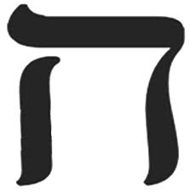
The letter hey looks like the outline of blood around the door.
What is special about the Hebrew letter Hey?
Do you remember the last time I taught about Passover and the Crucifixion? The sign above Jesus’ head on the cross read, King of the Jews. In Hebrew the first letters of each word spelled – Yod Hey Vav Hey. Just like on my tie.
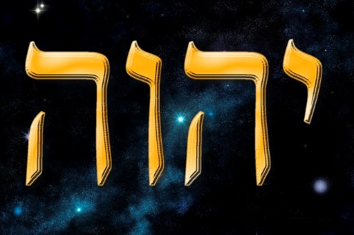

You add vowels and you get- Yahweh.
The blood on the door is a message to the death angel; this house is covered by the blood and this house has God’s abbreviated name on it. PASS OVER IT!!
One more side note. There is only one other command for us in the Bible concerning Door Posts.
We are to write God’s Word on our Door Posts and Gates.
Some might say, Herb, that’s Old Testament.
Well, --- do you have bad stuff happening at your house?
Or, evil stuff coming into your house.
Mabey, come into your house and stay?
Deuteronomy says, keep my commandments and get blessings, don’t keep my commandments and get curses. (As President Trump would say – NOT GOOD.)
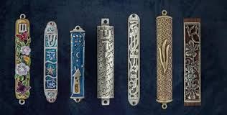

Here are several MEZUZAHS, they have the Word of God written in Hebrew inside. You can get them at Mardel’s or online. Mardell’s has one little display of Jewish stuff over by the Bibles.
Let’s look at scripture. Deut. 11:19-20 talks about the commandments of God.
V.19 “And you shall teach them to your sons, and talking of them when you sit in your house and when you walk along the road and when you lie down and when you rise up. V.20 “And you shall write them on the doorposts of your house and on your gates.
The Mezuzah is used to fulfill the commandment of writing God’s word on your doorposts and on your gates. They are to be a reminder to keep God’s Word and His promises on your mind and in your heart.
Many times, I have claimed that I shall be blessed “Coming In” and “Going Out.” Blessings are brought on by our obedience to His Word.
We can Resist the devil, demand he leave our house and clean the house thoroughly, but, if we do not post a No-Trespassing Notice, that this house belongs to God, demons will return with many more evil friends.
We can say our home belongs to God, but to receive the blessing there must be action on our part, doing what the Word says to do.
One more rabbit trail on Mezuzahs. Note the Hebrew letter on each of these. It is the letter Shin, spelled S H I N. It looks similar to our “W”.
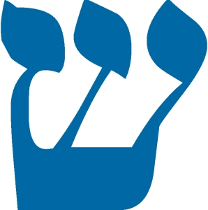
Our English language letters are used primarily for pronunciation. Not so with Hebrew. Each letter has a meaning.
Combining the meaning of multiple letters establishes the meaning of the word.
The letter Shin has the following meaning: Divine Power, Fire, Transformation.
What a deal, having Divine Power, Fire and Transformation guarding your doors. So much better than ADT or even Simply Safe.
One more rabbit trail.
How many does that make??
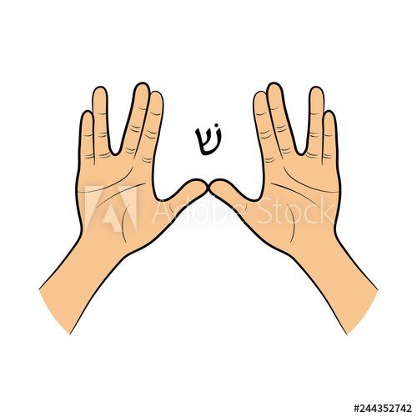
This hand sign is purported to be used by the High Priest when he spoke a blessing over the Israel. It creates the shape of the letter Shin. It takes some practice to get those fingers to operate that way.
You may remember Mr. Spock on Star Trek and his famous greeting: Live Long and Prosper. By the way, Leonard Nimoy was Jewish.
Now back to Passover at Exodus 12:8
V8. ‘And they shall eat the flesh that same night (Talking of the Passover Lamb), roasted with fire, and they shall eat it with unleavened bread (This is the first introduction of the symbolism of the sinlessness of our Lord Jesus, for He was without sin) and bitter herbs. V.9 ‘Do not eat any of it raw or boiled at all with water, but rather roasted with fire, both its head and its legs along with its entrails. V.10 ‘And you shall not leave any of it over until morning, but whatever is left of it until morning, you shall burn with fire. V.11 ‘Now you shall eat it in this manner: with your loins girded, your sandals on your feet, and your staff in you hand; and you shall eat in haste---it is the Lord’s Passover. (Not the Jews Passover, but the Lord’s. Some say, these Feasts are just for the Jews. No, these are the Lord’s Feasts.) V.12 ‘For I will go through the land of Egypt on that night, and will strike down all the first-born in the land of Egypt, both man and beast; and against all the gods of Egypt.
Exodus 13:1 Then the Lord spoke to Moses, saying, v.2. “Sanctify to Me (Sanctify means to set aside for God’s use) Set aside for My use every first-born, the first offspring of every womb among the sons of Israel, both of man and beast; it belongs to me.
Exodus 13:15b …Therefore, I sacrifice to the Lord the males, the first offspring of every womb, but every first-born of my sons I redeem.’
The putting of the lamb’s blood on the doorposts was to redeem the first born in that household.
We, the Church, are the first-born and we have been redeemed by our Savior, Jesus the Christ.
Let the redeemed of the Lord say so. Ps. 107:2,
Does this group, Say So?
Hebrews 12: 23. …to the general assembly and church of the first-born who are enrolled in heaven.
Are you the Church of the First Born, who are enrolled in heaven?
You--- Betcha!!!
Israel was instructed to start observing Passover, Pesach, while they were in the desert.
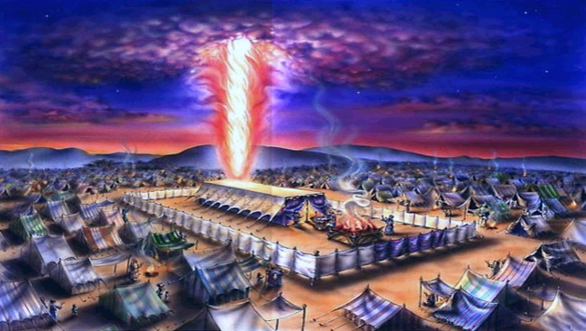
It was at these assigned times, Moedim, that the Lord would appear above the Tabernacle as fire at night and a cloud by day.
The Feast of Unleavened Bread starts the same day as Passover on the 14th of Nissan.
Jesus, the one Without Sin, the Sinless Offering is illustrated to us by the Feast of Unleavened Bread.
SINLESS
A little leaven, leaveneth the whole loaf. Jesus was completely without sin.

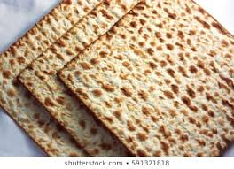
It is the custom at Passover to take three pieces of unleavened bread. Christians would associate these as: Father, Son and Holy Spirit, all unleavened, all without sin. The middle piece is broken and is referred to as the Afikoman in Hebrew.
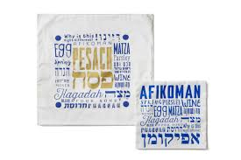
The middle piece is broken. Jews doing this for thousands of years, denying there is a relationship to Jesus.
During the Last Supper, Jesus said in 1Cor. 11:24 KJV And when He had given thanks, He broke it, and said, Take, eat: this is my body, which is broken for you: this do in remembrance of me.
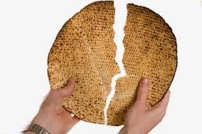
Take the middle piece, break it, wrap it in linen and hide it away, to be brought back out later during the meal. The symbolism is obvious to Christians, it represents Jesus.
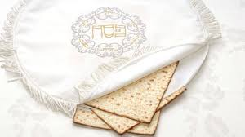
A linen bag is used for the middle piece and is called the Afikoman Bag.
John Hall will bring an Afikoman Bag for our Passover Observance.
Jesus, the unleavened Bread of life, sinless, is broken for our transgressions, buried in linen burial cloth and has been resurrected as a First Fruit Offering to God.
Many parts of the Passover Service are designed for children to participate. Here a little girl is holding up the Afikoman Bag. Her other hand is holding a monetary reward for finding the Bag.
I have been surprised at all the merchandise that is available for Passover.
This T-Shirt reads: Future Afikoman Finder.
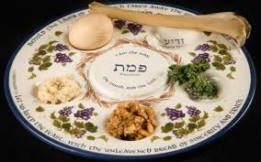
At the end of Passover, the Afikoman is recovered. The broken pieces are distributed and used to eat the sweet desert relish called Charoset.
C H A R O S E T
The sweetness is to remind us of being redeemed. The Jew’s Passover sacrifice was accepted by God and they were redeemed yet for another year. The Christian has been redeemed forever by the Blood of Jesus, the sweetness of that Redemption should never be forgotten.
At our Passover observance, we will be sharing some Charoset on a piece of unleavened bread in remembrance of the sweetness of our Redemption.
Let’s go to the end of the crucifixion. John 19:30. When Jesus therefore had received the sour wine, He said, “It is finished!” And He bowed His head, and gave up His spirit.
The term “It is finished” could also be stated as “Paid in Full.” This is an accounting term meaning, “All is paid for, the payment is finished.”
In Greek, the word is: TETELESTAI – It is finished, it is Paid in Full.
Under the Law of Moses, rebellious, willful sins could not be paid for or substituted with an animal sacrifice.
A rebellious son, that could not be corrected, was to be stoned to death. An animal sacrifice would not do.
Because of my teenage years, I have thought about this many times.
But, ------- JESUS PAID IT ALL!!!! Even for rebellious, willful sins. He paid for them all. Past, Present and Future.
Jesus paid it all. All to Him I owe. A-L-L
To a Jew, this must have been amazing and heavenly. To have willful sins, this heavy load, this threat, lifted off of you, to be removed. How freeing this must have been and still is.
Note: The law has NOT been removed, our punishment has.
Jesus Suffered the Punishment due us. He paid it ALL!!
HE PAID IT ALL!! All the punishment for our sins has been paid for.
We are to obey the Law, keep the Commandments based on our love of Jesus, not fear of punishment.
Let’s go to: John 19:31. The Jews therefore, because it was the day of preparation, so that the bodies should not remain on the cross on the Sabbath (for that Sabbath was a high day), asked Pilate that their legs might be broken, and that they might be taken away.
This scripture along with Mark 16:1-2 establishes which day of the week Jesus was crucified and thereby sets which day He was resurrected, which is the Feast of First Fruits.
Jesus was crucified on the day of Preparation, not Passover. This is the day you are to get everything ready to celebrate Passover, including grilling the Passover Lamb, for no work can be done on Passover. Jesus died at twilight, 3:00 Thursday afternoon. This is the exact time the High Priest was cutting the throat of the final lamb, the official lamb for the Temple Passover. That is why the High Priest declares, “It is Finished”, meaning, the last lamb has been sacrificed for Passover this year.
Jesus was taken down from the cross and placed in the tomb before sunset, that day, Thursday, when the High Sabbath, Passover began.
Mary Magdalene and Mary, the mother of James, could not go and anoint the body with spices for two days. The first day, Friday was a High Sabbath, Passover, no work could be done. The second day, Saturday, was a no go. Saturday was a regular Sabbath, again, no work can be done.
The two Marys’ went Sunday morning, the first day they were permitted to go.
Let’s look at Mark’s account of this.
Mark 16:1-2 And when the Sabbath was over, Mary Magdalene, and Mary the mother of James, and Salome, brought spices, that they might come and anoint Him. V.2. And very early on the first day of the week (Sunday), they came to the tomb when the sun had risen.
This puts Jesus in the grave three days and three nights, just as Jonah was in the belly of a great fish the same length of time.
THE RISEN JESUS.
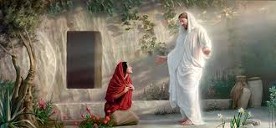
Why did Jesus tell Mary, “Stop clinging to Me”, many translations say, “Do not touch Me,” for I have not yet ascended to My Father?
Why – Do not touch me, when later He invites Thomas to touch him?
Jesus, Himself, was going to His Father to be The First Fruit Offering. The offering must be without defect and clean. Mary had been in a tomb with dead people looking for Jesus’ body and was unclean, by law, and anyone touching her would become unclean.
Until Jesus presented Himself to His Father, He had to remain without defect and clean, as the First Fruit Offering.
FIRST FRUITS
As believers, we are the First Fruits to our Lord.
James 1:18. In the exercise of His will He brought us forth by the word of truth, so that we might be, as it were, the first fruits among His creatures.
We are the First Born and the First Fruits. These are statements of Faith and promise. The First Born and First Fruits were sanctified, that is, both were set apart for God’s use.
These Firsts are given to God in Faith. Belief that He, God, will fulfill His Promises.
Promises that He will bless with many more births --------- and abundant crops. We are to give to God the first part, not the last. God blesses actions that are based on our faith in His promises.
Our tithe check is to be the first one written, not the last.
God’s laws on giving were designed to bless us, not to enrich God. God does not need our money, He owns the cattle on a thousand hills. But, if we will do what He says, that is, obey His laws, He will bless us.
Personally, I believe ALL of God’s Laws are designed to bless us. They are NOT rules designed by an angry God looking to punish us.
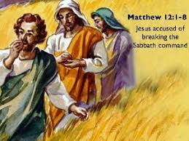
In fact, Jesus said the same thing when He was accused of breaking the sabbath. He and His disciples were walking through a grain field on the Sabbath. Not having anything to eat, they gathered some grain in their hand, rubbed their hands together to rub off the grain hulls, and ate the grain.
A Pharisee accused Jesus of not observing the Sabbath by harvesting and winnowing grain, working on the Sabbath, a sin punishable by stoning to death.
What was Jesus’s reply?
Mark 2:27 And He (Jesus) was saying to them, “The Sabbath was made for man, and not man for the Sabbath.
What did Jesus mean by this statement?
The Sabbath was designed to give man a day of rest. Just as God set the example, God created the heavens and the Earth in six days and rested on the seventh.
However, the Pharisees had added so many regulations and interpretations to what God meant as a blessing, they turned the Sabbath into a burden that no man could live under. Just like our governmental leaders of today, justifying their existence by writing new commands for us to do.
I believe all of God’s Laws, all of His Commands, all of His Instructions are designed to bless us, to help us live the Blessed Life.
So, are you saying we should live under the laws of God???
Only if you are interested in Living the Blessed Life!!!!!
The alternative to saying you are NOT under the law, is to proclaim that you are above the law.
Deuteronomy 28:1-14 says that IF you diligently obey the LORD, you get Blessings, BLESSINGS AND MORE BLESSINGS.
Now, it did not promise eternal life. Keeping the Law does not grant eternal life. Only faith in Jesus Christ and making Him Lord of your life promises eternal life. Even in the Old Testament, keeping the Law did not provide eternal life.
Romans 3:30-31. V.30 since indeed God who will justify the circumcised by faith and the uncircumcised through faith is one. V.31 Do we then nullify the Law through faith? May it never be! On the contrary, we establish the Law.
Romans 4:3 For what does the Scripture say? “And Abraham believed God, and it was reckoned to him as righteousness.
Reckoned is a good Southern word.
I reckon it’s about a mile down the road.
In the 1976 movie “The Outlaw Josey Wales”, Clint Eastwood, was the Outlaw Josey Wales, said, “I reckon so,” ------- He said it, 38 times in the movie.
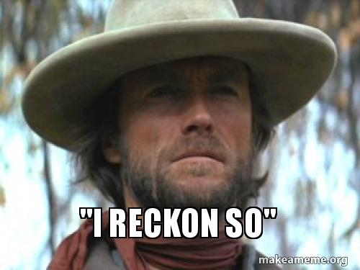
I know, I counted each one of them.
Did he actually say that 38 times? I reckon so.
Abraham believed God and it was reckoned to him as righteousness, right standing with God.
I want to briefly go into a subject that God has been stirring in me for several years. A subject that is actually the focal point of the Spring Feasts.
The close of the so-called Age of Law and the beginning of the Age of Grace.
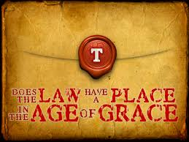
Some believe that these are mutually exclusive, that is, that the Law has been done away with completely.
Some believe that only certain parts of the Law have been done away with, such as the Ceremonial Law or the Sacrificial Law or Laws against sexual perversion or, (here’s a good one) the Dietary Laws.
People have taken their “Magic Erasers” and erased these from God’s Laws, even though they are written on our hearts. That part is really hard to do, even with a magic eraser.
Most of these are good people, with back-up scriptures in hand to justify their removal of God’s Laws. Over the past two years I have reviewed each of the scriptures that are used to exclude parts of God’s Laws. And it’s understandable how they could be used to come to that position.
However, there are scriptures that cannot be ignored, but usually are ignored, such as the one we just quoted.
Romans 3:31. Do we then nullify the Law through faith? May it never be! (Paul says.) On the contrary, we establish the Law.
What does Jesus have to say about this?
Matthew 5:17-19. V.17. “Do not think that I came to abolish the Law or the Prophets; I did not come to abolish, but to fulfill. V.18. “For truly I say to you, until heaven and earth pass away, (Oh!! Has heaven and earth passed away?) not the smallest letter or stroke shall pass away from the Law, until all is accomplished. V. 19. “Whoever then annuls one of the least of these commandments, and so teaches others, shall be called least in the kingdom of heaven; (Note: He did not say you’re going to hell, but that you’ll be a streetsweeper in heaven) but whoever keeps and teaches them, he shall be called great in the kingdom of heaven.
It gets even more direct in Hebrews.
Hebrews 10:28 Anyone who has set aside the Law of Moses dies without mercy on the testimony of two or three witnesses.
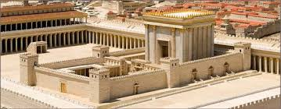
But Herb, some of the Laws are impossible for us to do today. There is no Temple in Jerusalem today, no Altar to roast the Passover Lamb and there are no Priests to offer the sacrifice.
What God has commanded us to do, He will provide a way.
There is definitely no Temple in Jerusalem today.
Where is God’s Temple today?
1 Corinthians 3:16 Do you not know that you are a temple of God, and that the Spirit of God dwells in you?
If God’s Temple is in here, where is the Brazen Altar?
Where is the Holy Place?
Where is the Holy of Holies?
Where is the Mercy Seat?
Where is the Ark of the Covenant with the Tablets of stone with the Law carved in them?
We sing songs nearly every week that describe how we are to enter God’s Temple, in here, and offer a sacrifice. “I will Enter His Gates.”
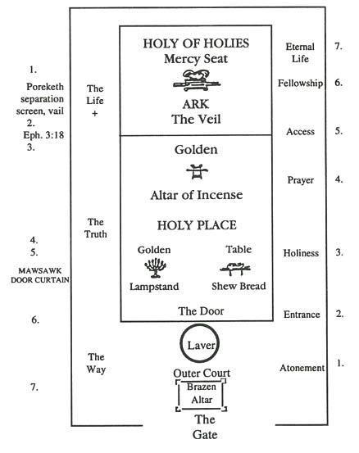
We enter His gates with (What!!) in our hearts. Not just casual or ritualized thanks, but heartfelt thanks. Thank you, Lord!! Thank You, God!!! Thank You!! Thank You God for all you have done for me, this very day!! Thank You!! Thank you, for all the things You do for me.
Now where are we doing this? Right here. Here is where God’s Temple is located today.
Ok, we’re in the gate.
Next, we enter His courts with Praise. God, you are a mighty God, You are a Merciful God, A Loving God.
Next, we are to take the sacrifice up to the Altar.
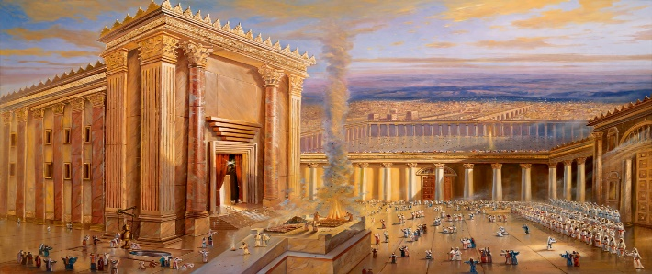
Wait, aren’t Priests to take the sacrifice to the altar? Yes, but we are to be Kings and Priests with Jesus and isn’t Jesus in us and we in Him.
All of this is happening where??? In us!!!
God requires a sacrifice, a lamb, every morning and evening.
This Sanctifies the Altar, it sets it apart for God’s use.
The Sanctification of the Altar, Sanctifies the Temple, making it acceptable for God’s use.
When we go to the Altar, inside us, to offer a sacrifice, -------
Wait, Wait, what about those that say, the age of offering sacrifices is over??? The Sacrificial System has been done away with.
Well, are we to quit singing the song about: We bring the Sacrifice of praise into the house (The house of the Lord, His Temple, in here) of the Lord. And we offer up to You _________. What? Sacrifices of: Praise, Thanksgiving and Joy.
If I had more time, I would continue in detail about the Brazen Laver, a large bowl of water that the Priests washed their hands and feet before going into the Holy Place, illustrating our cleansing and baptismal waters.
Next, into the Holy Place and the Show Table of Bread, Jesus is the Bread of Life and the Menorah, Jesus is the Light of the world. Jesus leads us into the Holy of Holies, through the curtain torn from top to bottom.
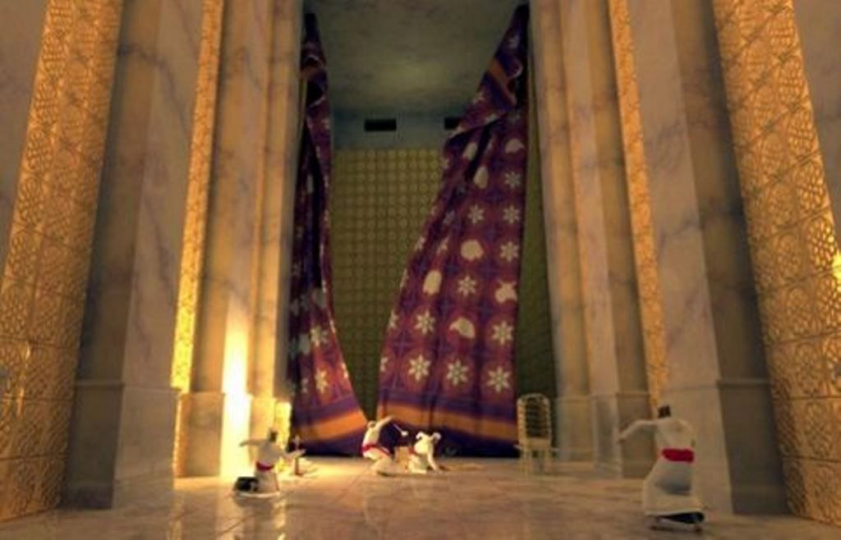
This is one of the things Jesus paid for ----- To have God’s Temple right here, in us, and to have access to a Most Holy God.
If you will offer the sacrifice twice daily, as commanded by God, He will abide with you, in you, in a very special way.
I have experienced this myself, for the last 30 days. This presence in the midst of you, in a very special way. It is a feeling of peace, of being at ease in every situation. It is a feeling that the presence of God has come to abide in you, to dwell in you, to live in the Temple inside you.
What is this abiding?
John 15:7 “If you abide in Me, and My words abide in you, ask whatever you wish, and it shall be done for you.
The blessing of His presence is well worth the effort. The sacrifice of time.
One final point, that I believe will tie all this together. It is concerning some of the last words spoken by Jesus from the cross.
Matthew 27:46 And about the ninth hour Jesus cried out with a loud voice, saying, “Eli, Eli, Lama Sabachthant?” that is, “My God, My God, why hast Thou forsaken Me?” I believe that God poured out all the sins of believers on Jesus, and a Holy God could not remain with sinful man. Jesus had felt the presence of the Father throughout His life. Suddenly it was gone and He felt forsaken, all alone.
There is a scripture that is commonly used to say, we are not under the law, when, I believe, it has quite a different meaning.
Romans 8:2 For the law of the Spirit of life in Christ Jesus has set you free from the law of sin and of death. If you eliminate the first and last phrase, you end up with: …Christ Jesus has set you free from the law…... This is what some want to believe and this is how they justify their position.
Let’s look at the last phrase first. What is this law? The Law of sin and death? This is not talking about the law in general, it is talking about one law, the law of sin and death.
The first phrase is talking about: The law of the Spirit of life.
We are talking about comparing: The law of life and the law of death.
This is not talking about physical life and death; it is talking about spiritual life and death.
What and where is the Law of sin and death????
Twice God tells Ezekiel: ‘O wicked man, you shall surely die, … Ez. 3:18 & 33:8
This is a spiritual death. Then what is it to die spiritually?
We are born spiritually dead. This is the Law of Sin and Death, separated from God. Those that believe in Christ become:
Alive,
Born again,
We have ETERNAL LIFE,
ETERNAL PRESENCE WITH GOD, right here in our spirit, spiritually alive.
So, when Jesus was separated from God on the cross because of our sins being placed on Him, He paid for our sins:
What did Jesus buy?
He paid for it, What - did - He - buy?
He bought our Eternal Life, meaning our Forever Presence of God, inside us.
Non-believers will be eternally separated from God.
Nothing can separate us from Christ. Rm. 8:35-39
Herb, if we are to start obeying all of God’s Laws, where do I start? There are hundreds of them. Such as: We are to observe Passover throughout our generations.
Start with the one we just talked about. The one that we are to: offer a sacrifice to God twice daily.
I will enter His Gates
I will enter His gates with thanksgiving in my heart,
I will enter His courts with praise.
I will say this is the day that the Lord has made,
I will rejoice for He has made me glad.
He has made me glad ---- And He will ---- If you will do this, He will make you glad.

Thank You Jesus,
Herb Smotherman

